**Cognizant - DN 4.0 I Deep Skilling**

**WEEK-8**

**GIT**

****Lab 1 –** Familiar with Git commands like git init, git status, git add, git commit, git push, and git pull.**

In this hands-on lab, you will learn how to

* Setup your machine with Git Configuration
* Integrate notepad++.exe to Git and make it a default editor
* Add a file to source code repository

**SOLUTION :**

**CODE:-**

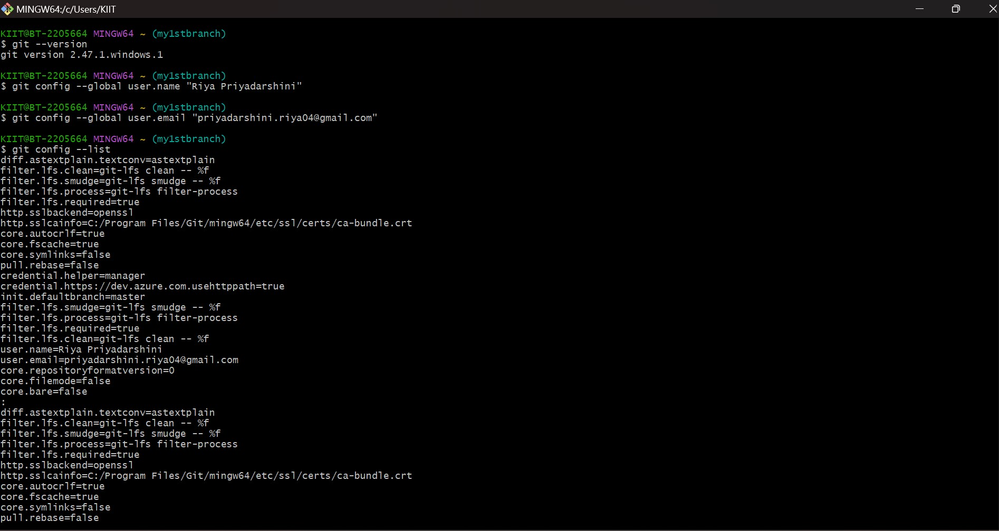

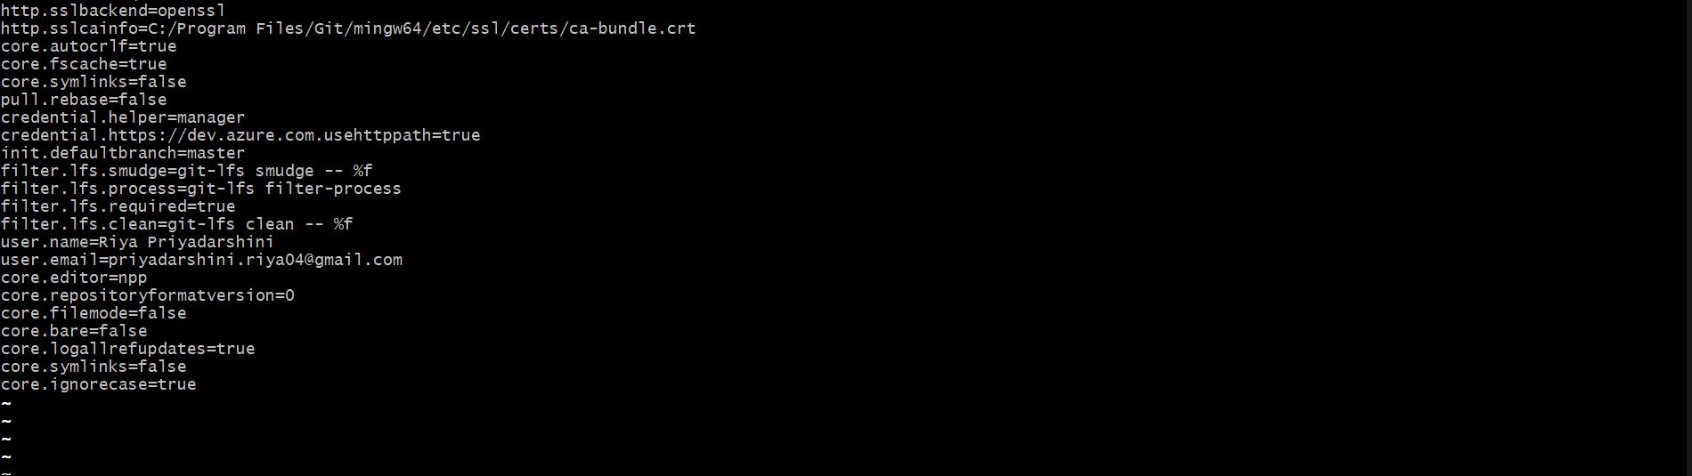

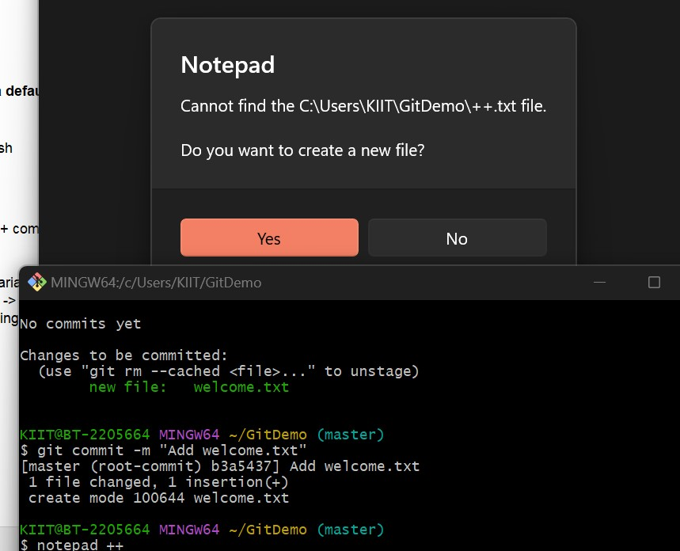

****Lab 2 – Explain how to ignore unwanted files using git ignore****

## **Objectives**

* Explain git ignore
* Explain how to ignore unwanted files using git ignore

In this hands-on lab, you will learn how to:

* Implement git ignore command to ignore unwanted files and folders

**SOLUTION :**

**CODE:-**

****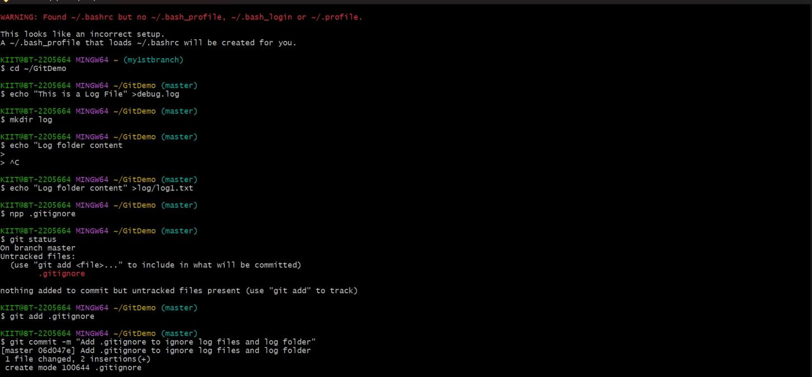****

****Lab 3 – Explain about branching and merging in Git.****

## **Objectives**

* Explain branching and merging
* Explain about creating a branch request in GitLab
* Explain about creating a merge request in GitLab

In this hands-on lab, you will learn how to:

* Construct a branch, do some changes in the branch, and merge it with master (or trunk)

**SOLUTION :**

**CODE:-**

****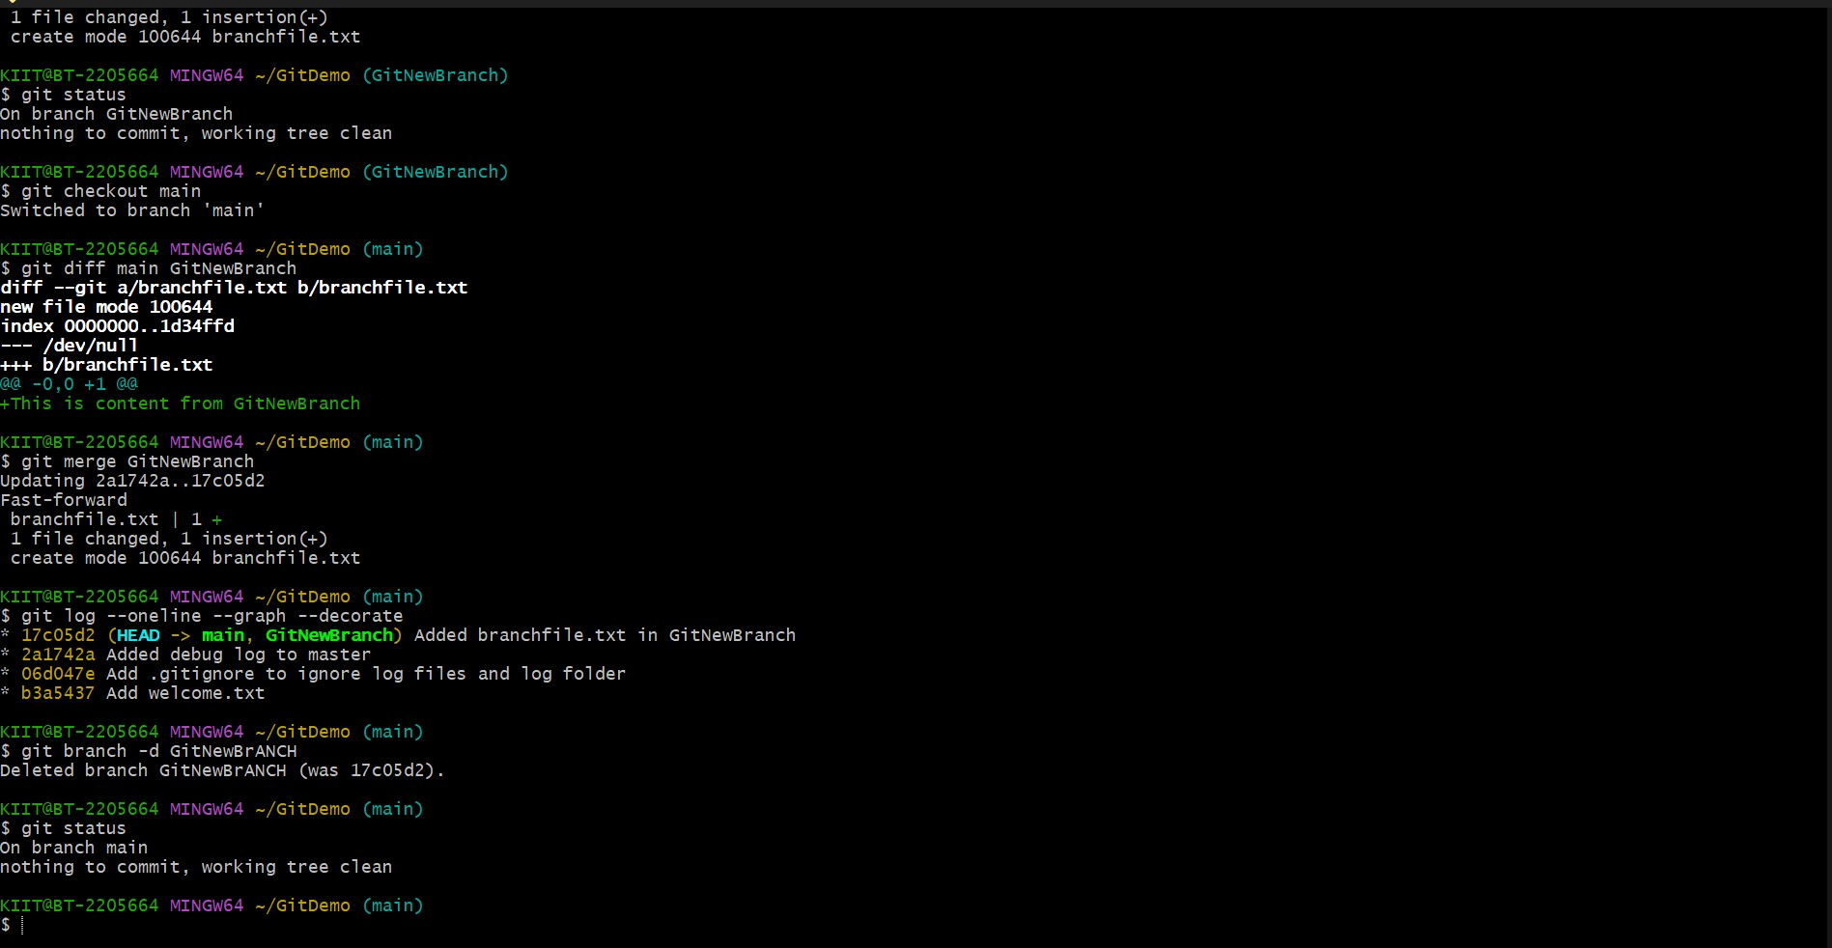****

****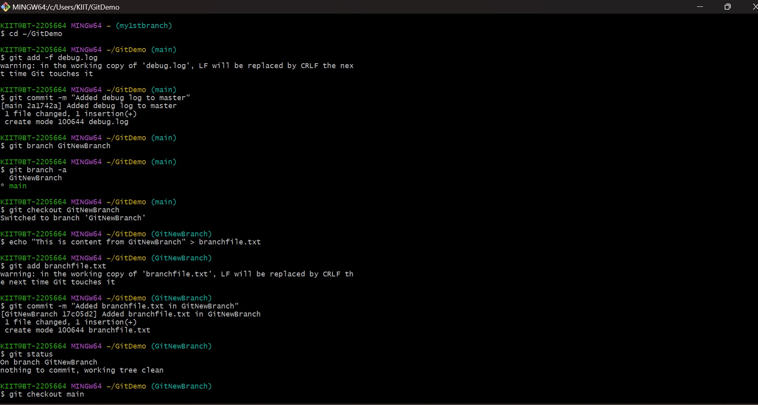****

****Lab 4 – Explain about resolving conflicts during merging.****

## **Objectives**

* Explain how to resolve the conflict during merge.

In this hands-on lab, you will learn how to:

* Implement conflict resolution when multiple users are updating the trunk (or master) in such a way that it results into a conflict with the branch’s modification.

**SOLUTION :**

**CODE:-**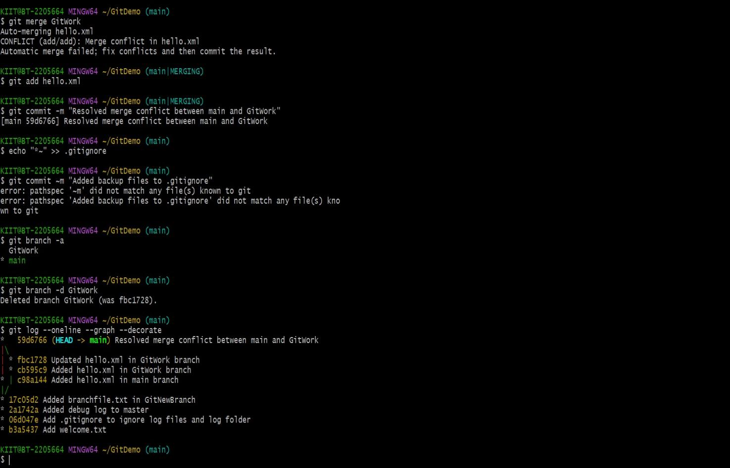

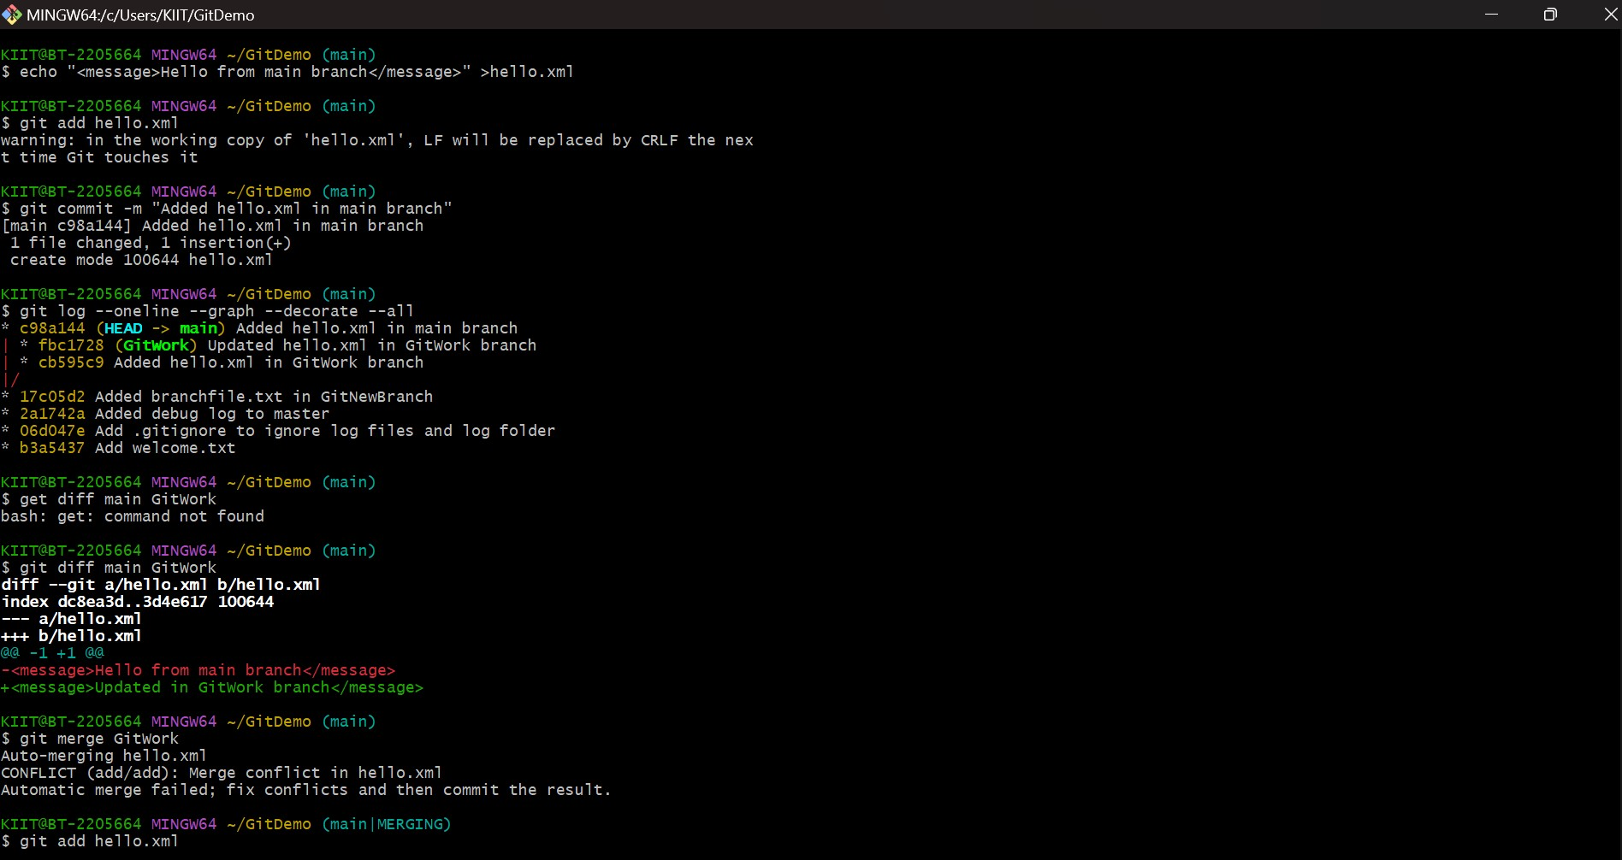

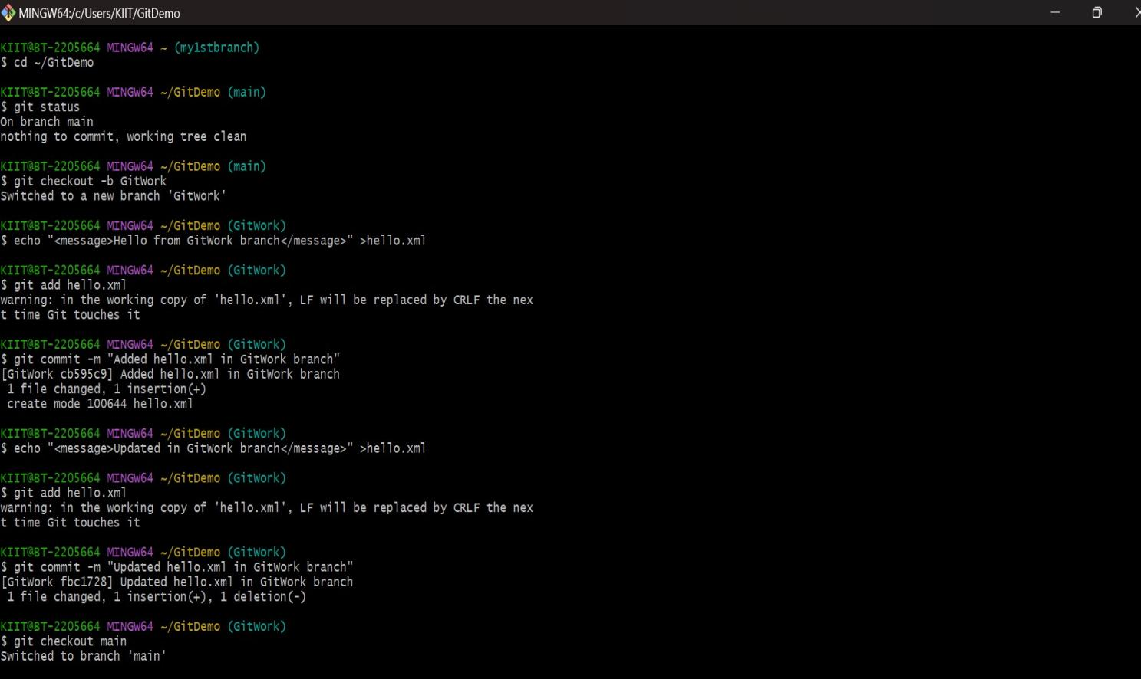

****Lab 5 – Explain how to clean up and push back to Github.****

## **Objectives**

* Explain how to clean up and push back to remote Git

In this hands-on lab, you will learn how to:

* Execute steps involving clean up and push back to remote Git.

**SOLUTION**

**CODE:-**

